Order Of Service

Singing: Psalm 24—CW page 73

Reading: Psalm 73—The Fate of the Wicked

Opening Hymn: CW 255

Reading: Acts 9:36-43

Request Hymn: CW Supplement 748

Reading: John 19:17-22

Sermon Hymn: CW 379

Sermon Text: Daniel 5:10-12

Thy Father

Prayer

The Apostles’ Creed, TLH page 12

Holy Communion

The Lord's Prayer

The Blessing

Closing Hymn: CW 327

* * * * * * * * * * *

Koinonia Hour

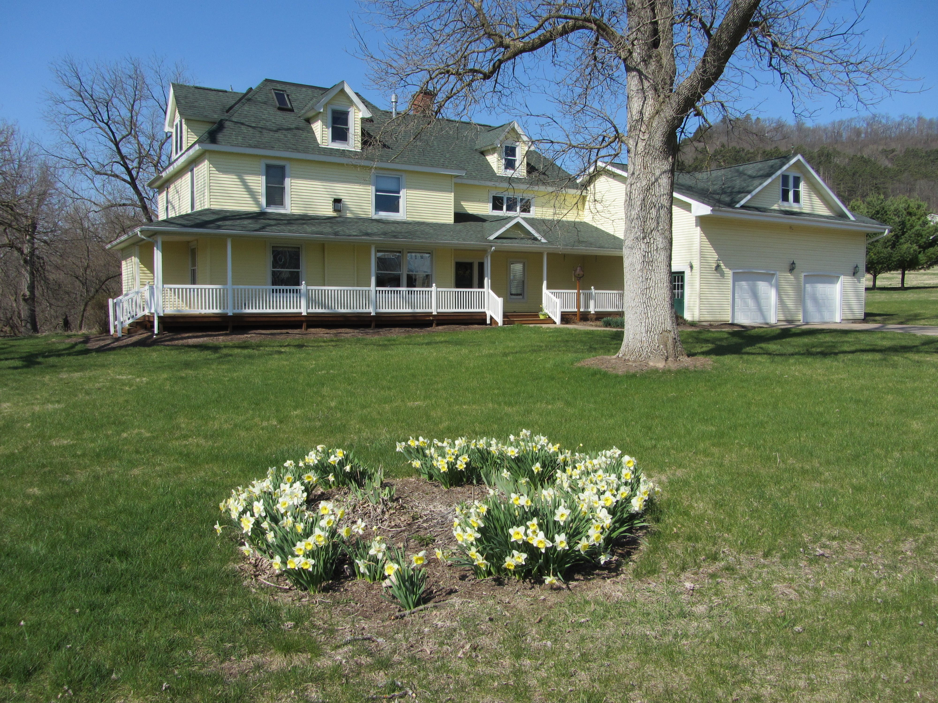

Spring At MGMF

Water
Of
Life

6 May 2018

W A T E R O F L I F E

Independent Christian Church—Conservative Lutheran Doctrine

Worship Service: 9:30 a.m. Bible Study: 10:45 a.m.

Larry Cooper, Pastor E-Mail address:
111 N. Ridge Road lcooper@wateroflife.cc
Coon Valley, WI 54623 Web Site:
Phone: (608) 452-2105 www.wateroflife.cc

* * * * * * * * * * * * * * * * * * * * * * * * * * *

Sermon Text: Daniel 5:10-12

Thy Father

* * * * * * * * * * * * * * * * * * * * * * * * * * *

Daniel 5:10 Now the queen, by reason of the words of the king and his lords, came into the banquet house: and the queen spake and said, O king, live for ever: let not thy thoughts trouble thee, nor let thy countenance be changed:
:11 There is a man in thy kingdom, in whom is the spirit of the holy gods; and in the days of thy father light and understanding and wisdom, like the wisdom of the gods, was found in him; whom the king Nebuchadnezzar thy father, the king, I say, thy father, made master of the magicians, astrologers, Chaldeans, and soothsayers;
:12 Forasmuch as an excellent spirit, and knowledge, and understanding, interpreting of dreams, and shewing of hard sentences, and dissolving of doubts, were found in the same Daniel, whom the king named Belteshazzar: now let Daniel be called, and he will shew the interpretation.

Related Reading: II Kings 4:18-20

18 And when the child was grown, it fell on a day, that he went out to his father to the reapers.
19 And he said unto his father, My head, my head. And he said to a lad, Carry him to his mother.
20 And when he had taken him, and brought him to his mother, he sat on her knees till noon, and then died.

